Which Kind of Shadow Exists?

Shadow for Single Characters
Same appearance group as emboss or imprint. Not relevant here.

Shadow as Attribute of a Border
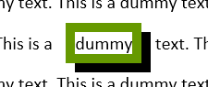
Only in OOXML, §17.3.4 and e.g. §17.6.2
Exists for run and paragraph, on/off attribute, no further settings.
Because we have already a shadow on paragraphs with more features, I would not follow this simple type of shadow in ODF specification.

Shadow on a Box

OOXML
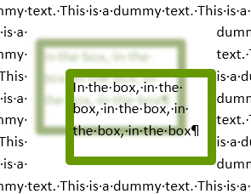
For graphic objects including text boxes as one of the Effects.
Elements <outerShdw> §20.1.8.45 and <innerShdw> §20.1.8.40 as child of a <effectLst> §20.1.8.26 element.

XSL-FO
not available

CSS3
CSS3 box-shadow
https://www.w3.org/TR/css-backgrounds-3/#misc .

ODF 1.3
draw:shadow 20.158, draw:shadow-color 20.159, draw:shadow-offset-x 20.160, draw:shadow-offset-y 20.161, draw:shadow-opacity 20.162
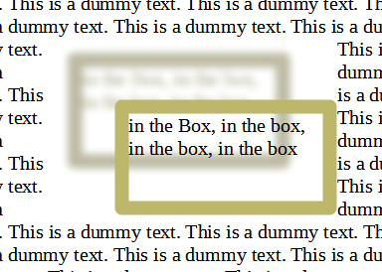
In <style:graphic-properties> 17.21
LibreOffice extension loext:shadow-blur
Example LibreOffice, combined with draw:stroke
style:shadow 20.359
In <style:graphic-properties> 17.21, <style:header-footer-properties> 17.5, <style:page-layout-properties> 17.2, <style:paragraph-properties> 17.6, <style:table-cell-properties> 17.18 and <style:table-properties> 17.15.
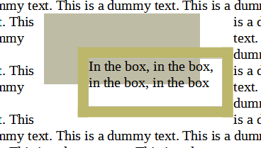
Example LibreOffice, combined with fo:border
Example LibreOffice, applied to paragraph and text span
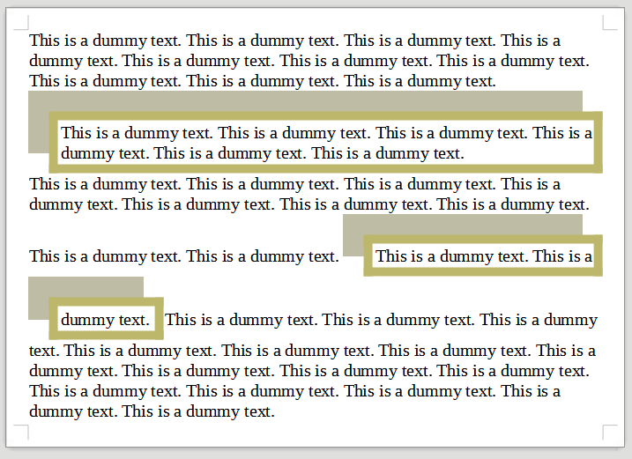

ODF 1.3 Current Text
20.359 style:shadow
The style:shadow attribute specifies a shadow effect.
The defined values for this attribute are those defined in §7.16.5 of [XSL], except the value inherit.
The shadow effect is not applied to the text content of an element, but depending on the element where the attribute appears, to a paragraph, a text box, a page body, a header, a footer, a table or a table cell.
The values of the style:shadow attribute are none or a value of type string 18.2.

Problems

Data Type string

Too wide data type
Currently style:shadow has the data type string. But in fact it is a restricted structure.
Currently the structure is only given by a reference to the not appropriate (OFFICE-3947) XSL attribute text-shadow.
From the (wrong) reference we get the structure
none | [<color> || <length> <length> <length>? ,]* [<color> || <length> <length> <length>?] | inherit
From the corresponding structure for CSS3 box-shadow we get
none | <shadow>#
<shadow> = <color>? && [<length>{2} <length [0,∞]>? <length>?] && inset?
For C33 the defining syntax is in https://www.w3.org/TR/css-values-3/
Links:
https://www.w3.org/TR/2001/REC-xsl-20011015/slice7.html#text-shadow
https://www.w3.org/TR/css-backgrounds-3/#misc

ToDo: Get the structure into the specification text and the RELAX schema.

More Than One Shadow
Both XSL and CSS3 allow a list of shadow effects in the string. The UI of MS Office only allows one shadow effect. Not sure, but I think, OOXML allows several shadow effects. LibreOffice allows only one shadow effect.
ToDo: Do we want to allow several shadow effects in style:shadow? That would be an extension compared to the draw:shadow-foo attributes.

Color Definition
CSS3 allows a wide range of ways to determine the color. https://www.w3.org/TR/css-color-3/
Most significant is, that the color may have an alpha channel.
XSL allows the color definitions from HTML4, which do not have alpha channel, but rgb() function and color keywords.
OOXML has in its srgbClr element a child element alpha.
ODF data type color allows only #rrggbb.
ToDo: Which color definition do we want to support?
ToDo: Do we want to include alpha channel in the color? Or allow draw:shadow-opacity in all places where style:shadow is allowed?
CSS3 has the concept of “currentColor” as default color of a shadow and in turn the color is optional. We do not have a “currentColor”.
ToDo: Make the color mandatory or set a default shadow color, e.g. #000000?

Position of Shadow
CSS3 and XSL use a Cartesian definition of the shape position with an offset-x and offset-y length (incl. negative), relative to the top-left corner of the bounding rectangle of the outer border edge. That is in first and second “length” in above structure.
OOXML uses a polar definition with specifying the origin in attribute algn, angle in attribute dir and radius in attribute dist.
I think, that here nothing is to do for ODF, because the position can be converted from one system to the other in the import and export filters of applications.

Blur
CSS3 and XSL have a blur radius in the third “length” value. CSS3 is more precise how to calculate the blur effect.
OOXML has attribute blurRad.
LibreOffice does currently not support a blur value in style:shadow, but has a blur effect for draw:shadow-foo defined shadows.
All agree to have a blur value. So I think, we should include it in the string.
ToDo: Add a draw:shadow-blur. Issue doesn’t exist yet, but it is already implemented in LibreOffice as loext:blur.

Transformation of Shadow
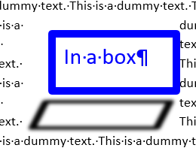
CSS3 has a “spread distance” as fourth “length” value. This value is added (subtracted if negative) to the width and height of the shadow and so changes the size of the shadow.
OOXML has attributes kx and ky for skew angle, sx and sy as scaling factors, whereby negative factors provide a flip of the shadow, and a boolean attribute rotWithShape to keep the shadow upright for a rotated object.
XSL has no transformation.
CSS3 and OOXML transformations are not compatible with each other.
ToDo: Do we want transformation of the shadow? If yes, which kind of transformation do we want? If yes, do we want to integrate it in the string or make a new attribute?

Inset Shadow
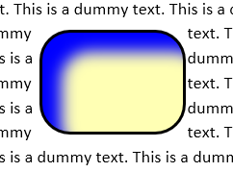
An “inset” shadow is an inner box-shadow, so as if the element were cut out of the canvas and shifted behind it and the canvas shadows onto the element. The illustration shows a yellow element with a blue shadow.
CSS3 supports an inset shadow with the keyword inset in the shadow structure.
OOXML has the element innerShdw (§20.1.8.40) for this kind of shadow.
XSL has no inset Shadow.
ToDo: Do we want to support “inset”?

Border and Shadow in Running Text
These problems affect Office-3843 too.

Overlap
XSL specifies (for text-shadow!) , “Shadow effects do not alter the size of a box, but may extend beyond its boundaries.”
CSS3 specifies, “Shadows do not influence layout and may overlap (or be overlapped by) other boxes and text or their shadows.” (§6.1.3).
That is contrary to the way MS-Word and LibreOffice draw the shadows, see illustrations above.
OOXML specifies for a shadow as attribute of a border, “For the right and bottom borders, this is accomplished by duplicating the border below and right of the normal border location. For the right and top borders, this is accomplished by moving the order down and to the right of its original location.” So the shadow effectively doubles the border area, see first illustration.
LibreOffice extends the shape too, but only in direction of the shadow.
ToDo: Do we want to treat a shadow as part of the border area? If yes or not, we will need the fo:margin-foo attributes on text span too, to allow authors to get CSS3 or MS-Word appearance.

Line Break
If a text span to which a border and shadow is applied is split into two lines, then LibreOffice and MS-Word treat each part as a separate box. Browser do not show border and shadow at the end of the line and not at the beginning of the next line and so treat it as one box.
CSS4 will have a property box-decoration-break with values clone and slice to allow both kinds.
https://www.w3.org/TR/css-break-4/#propdef-box-decoration-break
ToDo: Should ODF provide such property too? If not, which kind of break is used?

Indents
MS-Word draws a paragraph with border and shadow so, that the left and right text edge is the same as for a paragraph without border and shadow. So border and shadow overflow the page content area.
LibreOffice draws it so, that border and shadow are inside the page content area. So the text gets indents compared to a paragraph without border.
Word LibreOffice
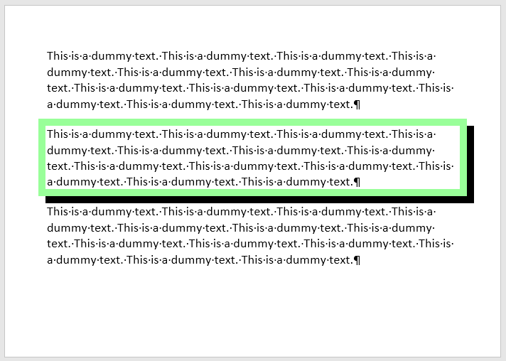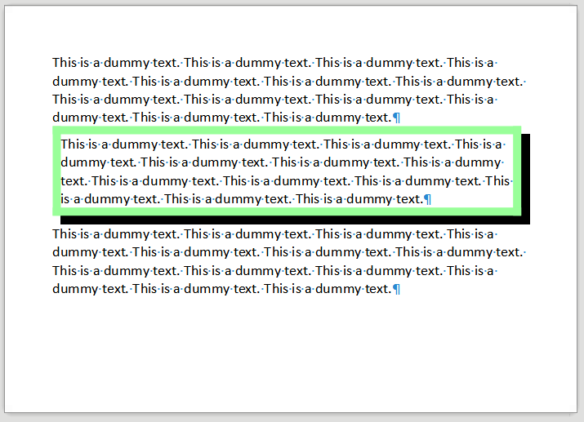
ToDo: Specify the desired indents.

Transparent Parts in Objects
Look at the above illustrations in regard to transparency. Especially look how the text of an object is handled. You will see different solutions.
ToDo: Is the entire object considered as opaque for generating the shadow, even if some parts of the object are transparent?

