19.15.1 new value for the chart:class attribute:
- chart:box - The values given by a chart:values-cell-range-address attribute on a <chart:series> element are used to create a boxplot as shown in the attached figure. Every series element creates a separate boxplot.
From the values for a series the following values are calculated: the minimum Q0, the first quartile Q1, the second quartile or median Q2, the third quartile Q3 and the maximum Q4.
If the value of the style property chart:vertical is true, then the boxplot is oriented as shown in this figure, otherwise it is rotated 90 degrees clockwise.
For the description below, P is the percentage given by the value of the style property chart:gap-width and W=2/(1+P), i.e. if P=100% then W=1.
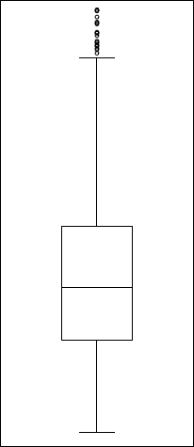
The nth vertical boxplot consists of a filled rectangle from Q1 to Q3 of width W centered at n with a horizontal line at Q2.
upper fence
lower fence
whisker
whisker
Q1
Q2
Q3
outliers
If the draw:outliers attribute of the relevant style:chart-properties element has the value true, then every value that is below Q2-(Q3-Q2)*1.5 or above Q3+(Q3-Q2)*1.5 is a near outlier and every value that is below Q2-(Q3-Q2)*3 or above Q3+(Q3-Q2)*3 is a far outlier. If the draw:outliers attribute of the relevant style:chart-properties element has the value false, then there are no outliers.
Let a be the largest value that is not an outlier. If Q3 is less than a, a horizontal line from n-W/4 to n+W/4 at a is drawn as an upper fence and the middle of the upper fence is connected to the point (n,Q3) as upper whisker.
Let b be the smallest value that is not an outlier. If Q1 is larger than b, a horizontal line from n-W/4 to n+W/4 at b is drawn as upper fence and the middle of the lower fence is connected to the point (n,Q1) as lower whisker.
If S is the percentage given by the value of the style property chart:radius-ratio, all near outliers are marked as filled circles centered at n and their respective value with diameter W*S and all far outliers are marked as stroked circles centered at n and their respective value with diameter W*S.

