Missing elements is UBL 2.4 when mapping to the eFTI subsets

The Efti data model: https://svn.gefeg.com/svn/efti-publication/Draft/EUsubsets/EU05a/5a1.htm
ADR: https://unece.org/sites/default/files/2023-01/ADR2023_Vol1e.pdf
Proposed new UBL element | EFTI element ID | GS1
Consignment / Carrier acceptance date (eFTI39)
Transport Equipment / Stowage position ID (eFTI385, eFTI9989) | eFTI998
Transport Equipment / Loaded Dangerous Goods (new ABIE) | ASBIE1087
Transport Equipment/ Carried Transport Equipment (Maybe the ID only) | ASBIE1092
Loaded Dangerous Goods / Gross Weight | eFTI238
Loaded Dangerous Goods / Limited Quantity Code | eFTI261 (RID)
Transport Event / Certifying Party | ASBIE1062 (CSD)
Goods Item / Operational category code – Commodity Code / Nature Code ?? | eFTI700
Consignment / Regulatory Procedure | ASBIE1126
Consignment /Arrival Transport Event | ASBIE1395
Carrier Party / Confirmed data set authentication / Authentication Code -- Party Authentication?? | ASBIE1033
Hazardous Item / Proper shipping Name | eFTI251
Road Transport / Trailer Licence Plate | eFTI378
Hazardous Item / Regulation Code
Hazardous Item / Packaging Level Danger Code | eFTI236
Hazardous Item /Marking Text – shipping marks? | eFTI301
Hazardous Item / Pollutant Level Code
Hazardous Item / Gross Weight | eFTI238
Hazardous Item / Hazard Type Code | eFTI240
Hazardous Item / Special Provision ID | eFTI256

Hazardous Item / Additional Hazard Classification ID
Hazardous Item / Gross Volume | eFTI336

Hazardous Item / Pollutant Indicator

Hazardous Item / Marine Pollutant Indicator
Hazardous Item / Explosive Cargo Net Weight | eFTI249
Hazardous Item / Proper Shipping Name | eFTI251

Hazardous Item / Overpack Information

Hazardous Item / Shipper Emergency Declaration Information

Hazardous Item / Limited Quantity Code

Hazardous Item / Packaging Recycle Indicator
Hazardous Item / Radioactive Material (New ABIE) | ASBIE1069
Hazardous Item / Applicable Radioactive Isotope (New ABIE) | ASBIE1070
Hazardous Item / Dangerous Goods Logistics Package (New ABIE) | ASBIE1073
Radioactive Material / Radionuclide Name | eFTI290
Radioactive Material / Special Form Information | eFTI287
Radioactive Material / Transport Index Number | eFTI288

Radioactive Material / Criticality Safety Index Number
Radioactive Material / Radioactive Package Transport Index Code | eFTI289

Applicable Radioactive Isotope / Activity Level Measure
Dangerous Goods Logistics Package / Package Quantity | eFTI296
Dangerous Goods Logistics Package / Type | eFTI297

The GS1 model for Hazardous goods

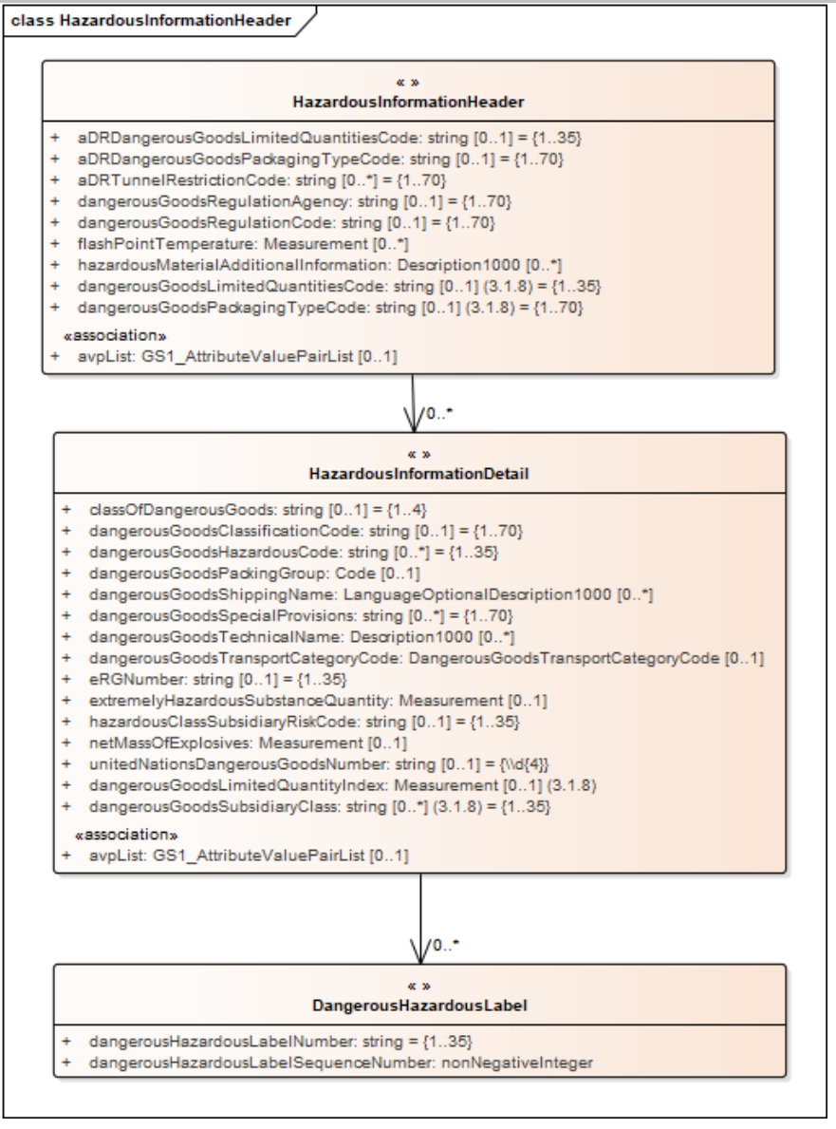

Hazardous Information for the GS1 model can be found at section 3.14 at https://www.gs1.org/docs/gdsn/3.1/BMS_GDSN_Trade_Item_Modules_r3p1p27_i1p43_February_26_2024.pdf

