Notification Document and Movement Document.

Overall description and Process:
The snippets shown below are taken from:
https://eur-lex.europa.eu/legal-content/EN/TXT/PDF/?uri=CELEX%3A02006R1013-20210111

- Both documents must be used when moving waste across borders to/from/within the European Union.
  - One Notification Document before transportation starts. Can be referred to by many Movement Documents.
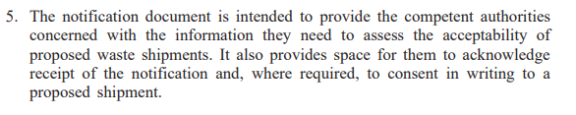
  - One/multiple Movement Documents, one for every transport, referring to the Notification Document.
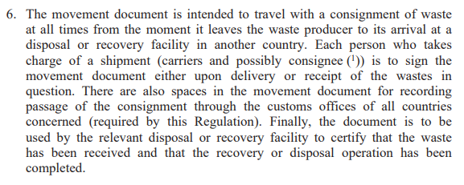
- The documents are designed to be printed on paper, but digital versions are allowed.
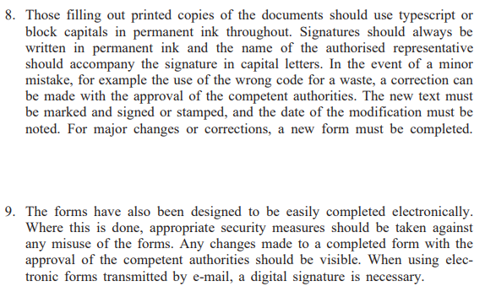
- Notification Document is sent to the Authorities of the dispatching country. These Authorities are responsible of forwarding the information to Authorities in Transit and Receiving countries.

- All involved Authorities will respond to the Notification.
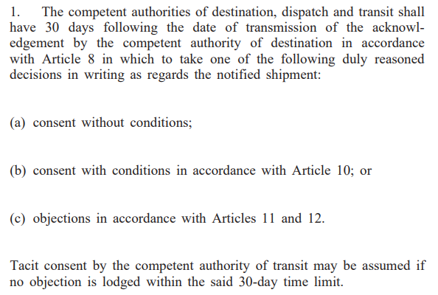
- Movement Document shall before transport starts be sent, signed by the Notifier, to Authorities and Consignee.
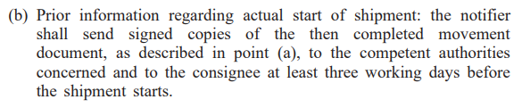
- Movement Document, together with the consent from Authorities, shall also accompany the waste during transportation.
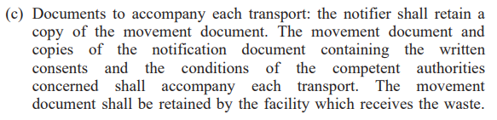
- The consignee shall send the Movement Document, now signed by all involved, to Authorities and to Notifier.
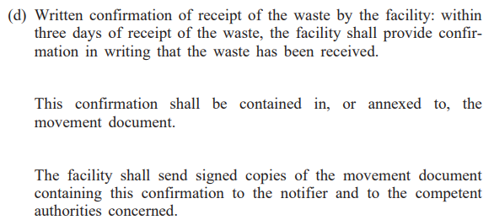

- Communication with Authorities:
  - Paper (Mail, Fax, eMail, electronic form (pdf)).
  - EDI.

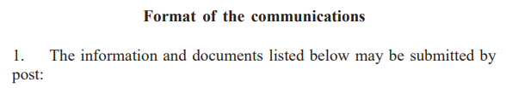
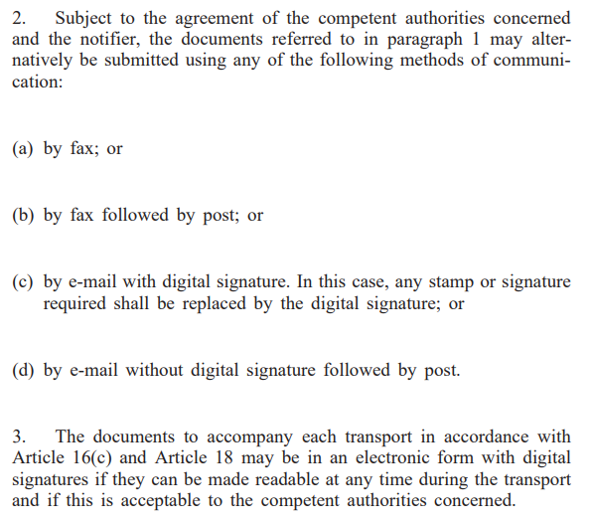
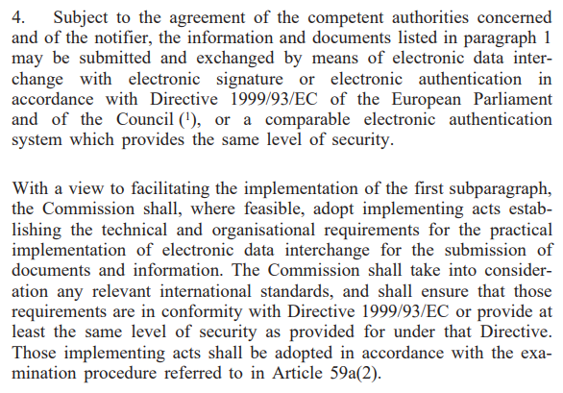

Content of the Notification Document:

Content of the Movement Document:

- Block 1.
  - Reference to the Notification Document.
- Block 2.
  - Sequence number of Movement Document referring to the Notification Document.
  - Estimated total no of shipments for the Notification Document (as in the Notification Document).
- Block 3, Notifier Party.
  - Company registration number.
  - Name/Address.
  - Contact information.
- Block 4, Consignee (many times the same as the Disposal Facility, but not always).
  - Company registration number.
  - Name/Address.
  - Contact information.
- Block 5.
  - Quantity, weight in tonnes.
  - Quantity, volume in m3.
- Block 6.
  - Start date of the Shipment.
- Block 7, Packaging/Handling.
  - Package type.
  - No of packages.
  - Special handling required (y/n).
  - (Handling instructions – not included today but in a digital document I would recommend to include it.)
- Block 8, Carrier Party (repeated n times).
  - Company registration number.
  - Name/Address.
  - Contact information.
  - Means of transport.
  - Date of Transfer.
  - Signature.
- Block 9, Waste generator Party.
  - Company registration number.
  - Name/Address.
  - Contact information.
- Block 10, Disposal or Recovery Facility Party.
  - Type, Disposal or Recovery.
  - Company registration number.
  - Name/Address.
  - Contact information.
- Block 11, Disposal/Recovery action.
  - D-code.
  - R-code.
- Block 12.
  - Designation and composition of the waste.
- Block 13, Physical characteristics.
  - Indicate physical characteristics of the waste at normal temperatures and pressures.
- Block 14, Waste identification.
  - Relevant waste-codes.
- Block 15.
  - Notifier’s signature.
- Block 16.
  - Additional information. Can be repeated.
- Block 17.
  - Consignee’s signature.
- Block 18, Receipt confirmation by Disposal/Recovery Facility.
  - Type of Facility – Disposal or Recovery.
  - Date for reception.
  - Quantity received in tonnes.
  - Quantity received in m3.
  - Accepted, y/n.
  - Date of Disposal/Recovery.
  - Signature confirming receipt.
- Block 19.
  - Signature for Disposal/Recovery.
- Block 20, Exporting country.
  - Signature.
- Block 21, Importing country.
  - Signature.
- Block 22, can be repeated.
  - Country name, export.
  - Point of exit.
  - Country name, import.
  - Point of entry.

